

**Sri Lanka Institute of Information Technology**

**V – Motion Migration in vSphere Client**

**De Silva D.W.N**

**(IT13115494)**

**Weekday**

**Introduction**

vMotion is the technology with which active virtual systems can be migrated from one ESX-host to another without any interruption to the virtual machines themselves or to their provided services.

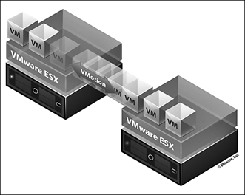

In this document explain, how to configure Vmotion 2 ESXi hosts connected together by a dedicated network cable. Using network cables 2 since in vSphere 5 can use multiple network connections to load the VMkernel swing between 2 cards and much reduced time migration of a virtual machine from one host to the other. It helps to migration between hosts very fast.

Vmotion can be used to;

* Improve overall hardware utilization.
* Allow continued virtual machine operation while accommodating scheduled hardware downtime.
* Allow vSphere Distributed Resource Scheduler (DRS) to balance virtual machines across hosts.

**Requirements for V- Motion Migration**

* Having a Virtual Center.
* Visibility to all storage (Fiber Channel, iSCSI, or NAS) used by the virtual machine.
* 2 have physical servers with ESXi installed.
* Access to the same physical networks.
* Having a Gigabit network cable to connect from one server to another directly.
* To do vMotion Migration in one physical machine it need at least 12GB of RAM to run 2 separate VMware EXSi baremetal hypervisors.
* Compatible CPUs.

**Process of V- Motion Migration**

First we have to identify the characteristics of CPU, whether its compatible or not. One way to identify CPU characteristics is to use the VMware CPU identification utility.

**Compatibility requirements**

There are several methods which can be used to address vMotion CPU compatibility requirements:

* Procure servers with identical CPUs.
* Compatibility masking in the vSphere client.
* Enhanced vMotion Compatibility (EVC)
* Automatically masks off CPU incompatibility
* A feature of DRS clusters

**vMotion Migration steps**

Moves made on the physical server. Connect a network cable to "Direct Attach" which means to connect directly from one server to the other server. Actions to be taken through vSphere Client connected to Virtual Center. Connect to Virtual Center and gain access to one of the servers 2.

Select the tab **Configuration-> Network Adapters**and we see that have visibility of the new connections.

**[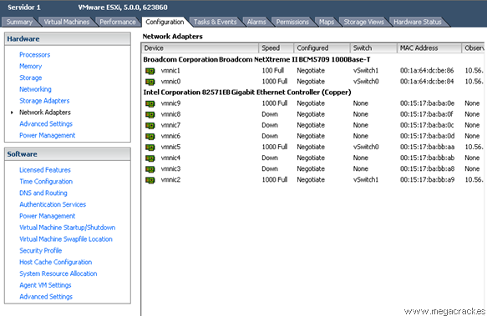](http://en.megacrack.es/wp-content/uploads/2012/10/Vmotion-ESXi-0.png)**

Then go to the tab called **Configuration-> Networking**

**[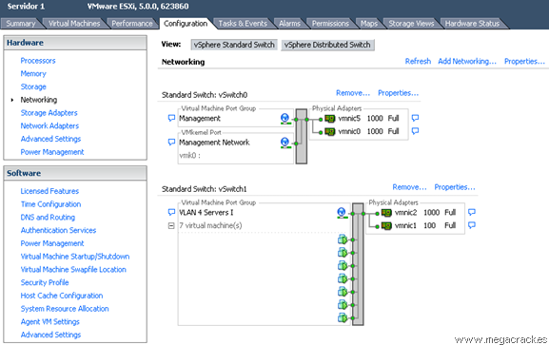](http://en.megacrack.es/wp-content/uploads/2012/10/Vmotion-ESXi-1.png)**

Click on **Add Networking** to create the vSwitch.

**[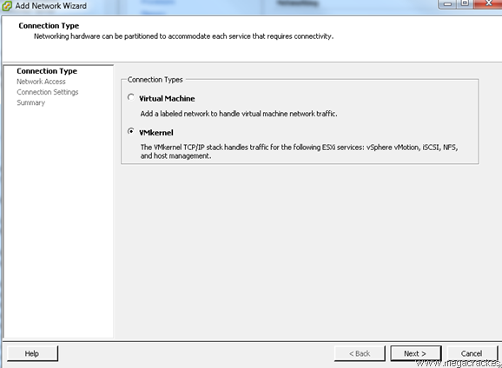](http://en.megacrack.es/wp-content/uploads/2012/10/Vmotion-ESXi-2.png)**

Select **VMKernel** and click on **Next.**

**[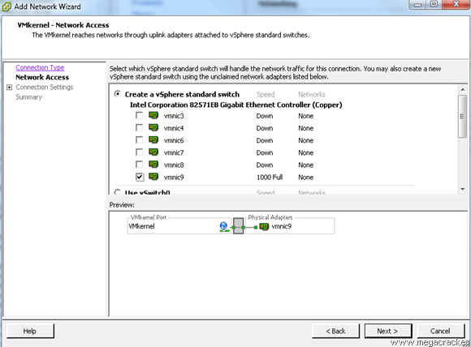](http://en.megacrack.es/wp-content/uploads/2012/10/Vmotion-ESXi-3.png)**

Making a network card or cards that have connected from one server to another (in our case **vmnic9)** And click on **Next.**

**[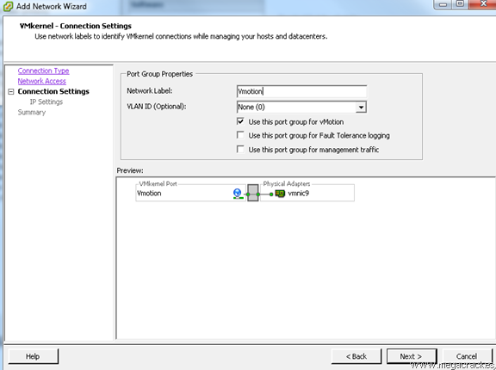](http://en.megacrack.es/wp-content/uploads/2012/10/Vmotion-ESXi-4.png)**

**Use this port group for vMotion.**

Wrote a **Label Network** different if you want (optional) and click on **Next.** 

**[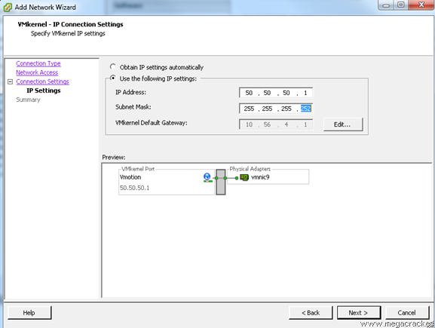](http://en.megacrack.es/wp-content/uploads/2012/10/Vmotion-ESXi-5.png)**

**Use the following IP settings:**

**IP Address: 50.50.50.1**

**Subnet Mask: 255.255.255.252**(Since we will use only 2 ip's).

Click on **Next.**

**[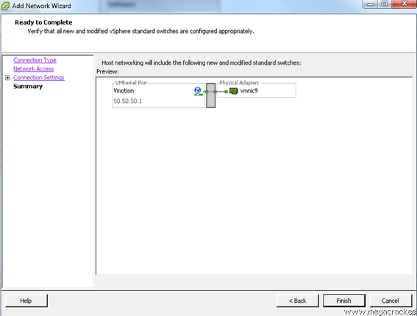](http://en.megacrack.es/wp-content/uploads/2012/10/Vmotion-ESXi-6.png)**

Click on **Finish.**

**[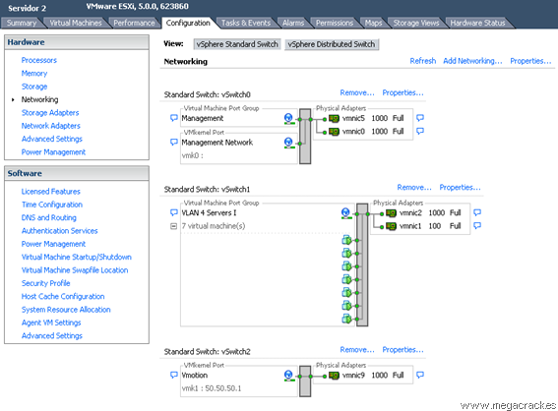](http://en.megacrack.es/wp-content/uploads/2012/10/Vmotion-ESXi-7.png)**

New virtual switch with Vmotion has been created.

Connect to another server involved.

Select the tab **Configuration-> Network Adapters**and we see that we have visibility of the new connections.

**[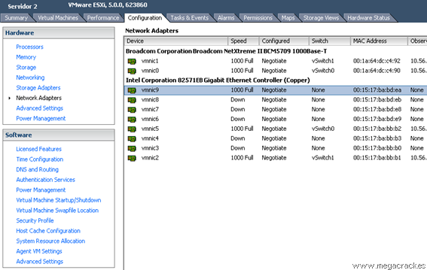](http://en.megacrack.es/wp-content/uploads/2012/10/Vmotion-ESXi-8.png)**

Go to the tab **Configuration-> Networking**

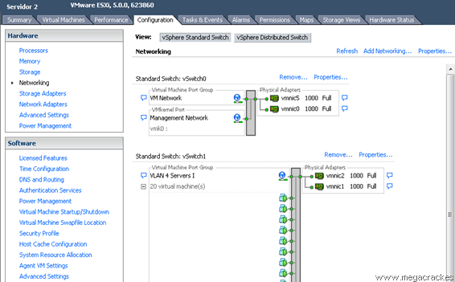

Click on **Add Networking** to create the vSwitch.

**[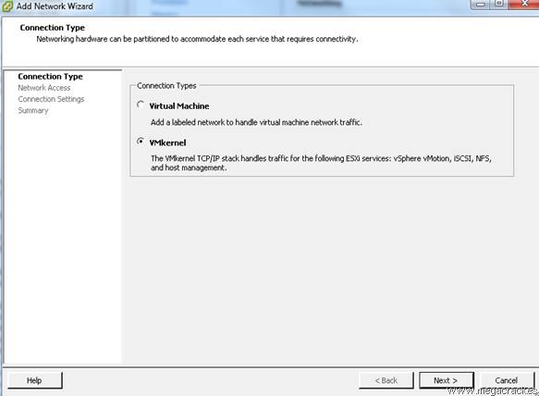](http://en.megacrack.es/wp-content/uploads/2012/10/Vmotion-ESXi-21.png)**

Select **VMKernel** and click on **Next.**

**[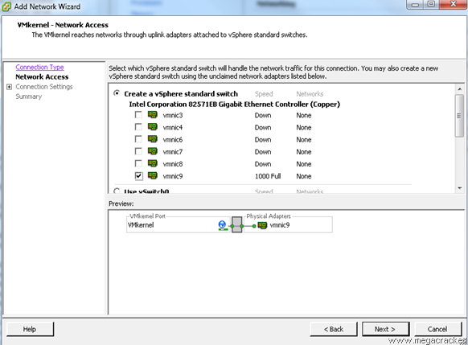](http://en.megacrack.es/wp-content/uploads/2012/10/Vmotion-ESXi-31.png)**

Making a network card or cards that have connected from one server to another (in our case **vmnic9**) And click on **Next.**

**[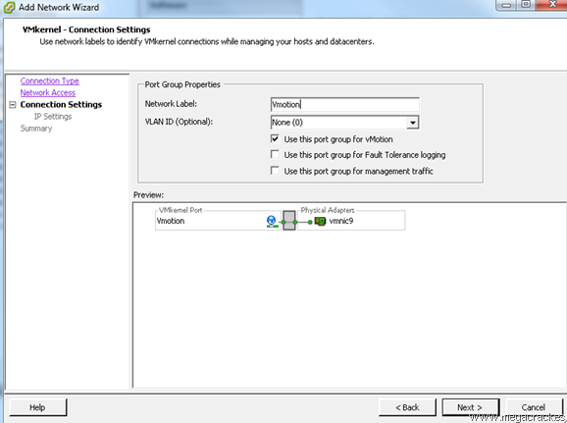](http://en.megacrack.es/wp-content/uploads/2012/10/Vmotion-ESXi-41.png)**

We set **Use this port group for VMotion.**

We wrote a **Label Network** different if you want (optional) and click on **Next.** We for example we put **Vmotion.**

**[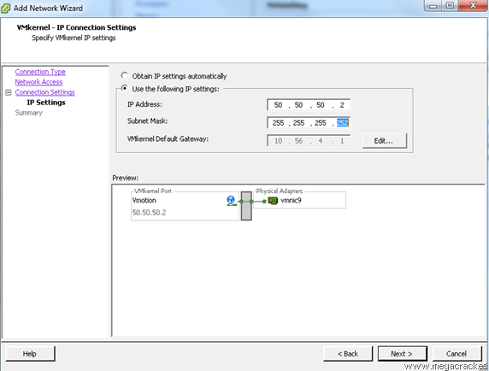](http://en.megacrack.es/wp-content/uploads/2012/10/Vmotion-ESXi-10.png)**

We set **Use the following IP settings:**

**IP Address: 50.50.50.2**(This ip must be different from the server that we configured earlier 1).

**Subnet Mask: 255.255.255.252**(Since we will use only 2 ip's).

Click on **Next.**

**[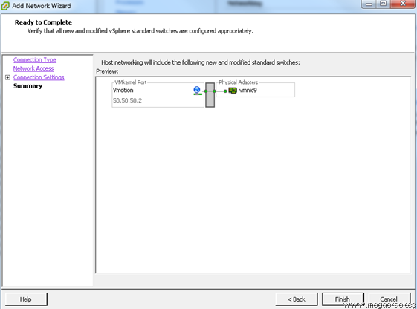](http://en.megacrack.es/wp-content/uploads/2012/10/Vmotion-ESXi-11.png)**

Click on **Finish.**

And now what we will do to ensure that the entire system is working properly migrate a VM from one ESXi to the other using Vmotion functionality you just configured.We press the right mouse button on a virtual machine.

**[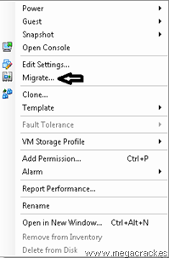](http://en.megacrack.es/wp-content/uploads/2012/10/Vmotion-ESXi-12.png)**

Click on **Migrate.**

**[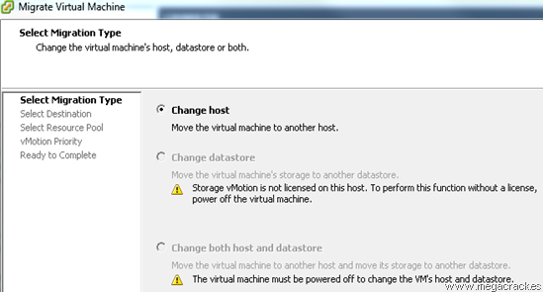](http://en.megacrack.es/wp-content/uploads/2012/10/Vmotion-ESXi-13.png)**

Click on **Next.**

**[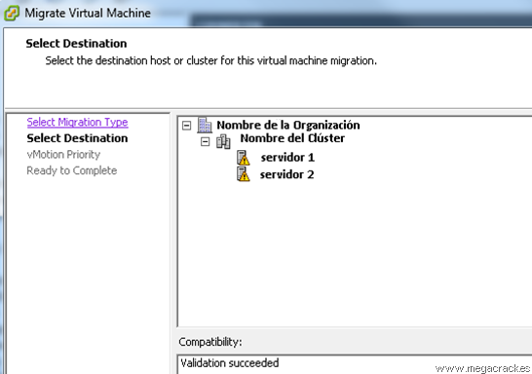](http://en.megacrack.es/wp-content/uploads/2012/10/Vmotion-ESXi-14.png)**

Select the target server where we will move the virtual machine.

Click on **Next.**

**[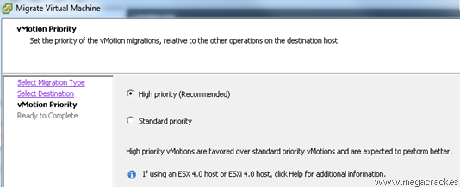](http://en.megacrack.es/wp-content/uploads/2012/10/Vmotion-ESXi-15.png)**

Click on **Next.**

**[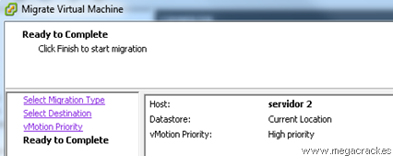](http://en.megacrack.es/wp-content/uploads/2012/10/Vmotion-ESXi-16.png)**

Click on **Finish**to start the migration.

**[ESXi Vmotion 17](http://en.megacrack.es/wp-content/uploads/2012/10/Vmotion-ESXi-17.png)**

Perfect the system has been migrated from an ESXi host to another without losing the service and in just 47 seconds, if we set up another network card this time has reduced considerably, as we have said before Vmotion is able to use multiple cards network for migration.